# Using Google Sheets for the Invoice Form

These instructions are for providers that do not have Microsoft Excel installed on their laptop, phone, or tablet.

**Mobile Users:** Please make sure you have the Google Sheets and Google Drive apps downloaded to your phone.

**Google Sheets Links:**

* [Google Sheets App for Android](https://play.google.com/store/apps/details?id=com.google.android.apps.docs.editors.sheets&pcampaignid=web_share)
* [Google Sheets App for iPhone](https://apps.apple.com/us/app/google-sheets/id842849113)

**Google Drive:**

* [Google Drive App for Android](https://play.google.com/store/apps/details?id=com.google.android.apps.docs&pcampaignid=web_share)
* [Google Drive App for iPhone](https://apps.apple.com/us/app/google-drive/id507874739)

**Step 1:**

Select the invoice form you need to fill out. YOU MUST SELECT FROM A LINK BELOW – DO NOT USE ANY OF THE OTHER LINKS PROVIDED TO YOU.

* [Pathway 1 Invoice Form](https://docs.google.com/spreadsheets/d/1PpopxaWUNI8eeamIdEkEe6aeq1axSp5p/edit?usp=sharing&ouid=104607596424444985034&rtpof=true&sd=true)
* [Pathway 2 Invoice Form](https://docs.google.com/spreadsheets/d/1PzfG880NvNp1UglStXcPQNeTu3O00fjn/edit?usp=sharing&ouid=104607596424444985034&rtpof=true&sd=true)

**Step 2:**

Once the file opens in google sheets, you will need to make a copy in your personal google drive.

To do this, click file at the top, then select ‘Make a copy’.

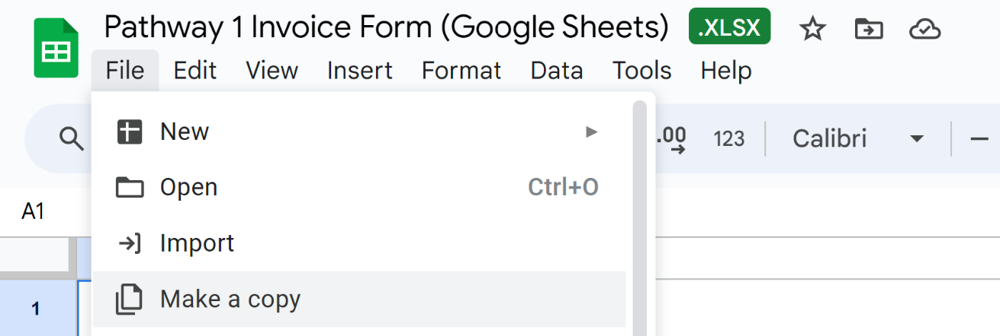

For Mobile users, you will need to click the three dots ‘…’ then navigate to ‘Share & export’

**This will open the file in a new window, and you can now start filling out your invoice!**

**Step 3:**

Submit your invoice form using the link to the dropbox/portal like usual.

## Helpful Tip!

To use this sheet in the future, you can simply follow the steps above again OR you can go to your ‘My Drive’ on Google Drive to access the invoice form.

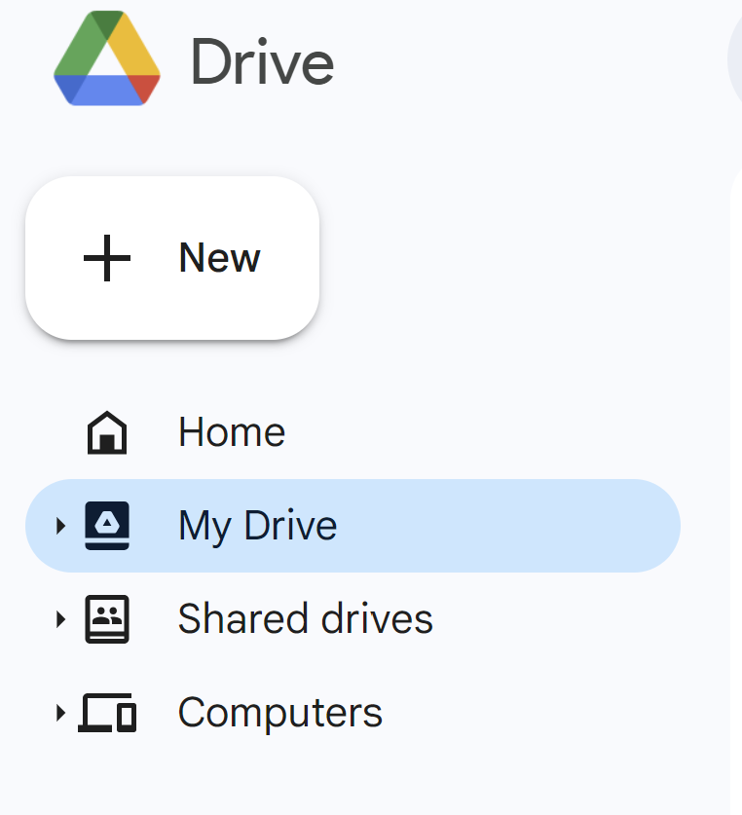

For mobile users, you can access the invoice form by opening the Google Drive App and navigating to ‘My Drive’ by going to ‘Files’. Alternatively, you can open the Google Sheets app and find your file there.